ASSIGNMENT NO 01

Submitted by: Tayyaba munir
Submitted to : Ma’am Yasmeen
Registration no : SP23-BSE-025
Subject : Advanced Web

Task 1: project structure
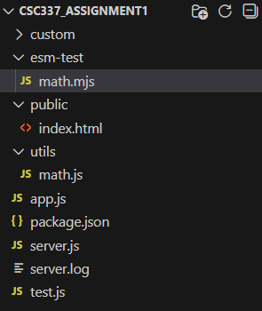
Output:
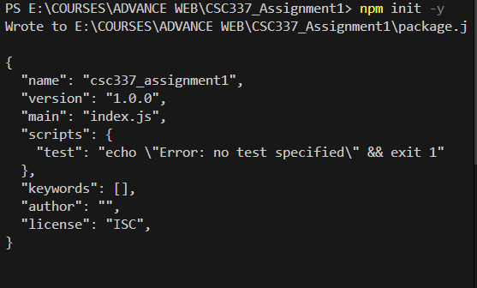
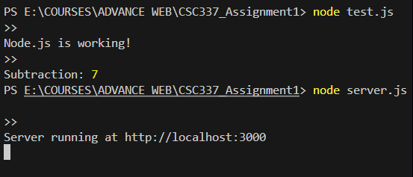
Task 2: CommonJS and ES Modules:
CommonJS uses require() and module.exports, while ES Modules use import and export. ES Modules are modern and supported in new JavaScript standards.
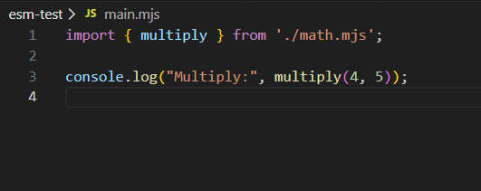
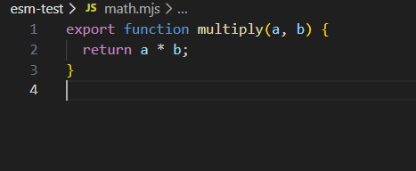
Output:
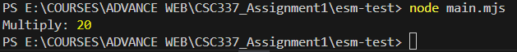
Task 3: comparing an I/O-heavy application and a CPU-heavy application
I/O Heavy App: File upload system, chat app
CPU Heavy App: Video editing, image processing
Node.js is better for I/O because it is non-blocking.
Example:
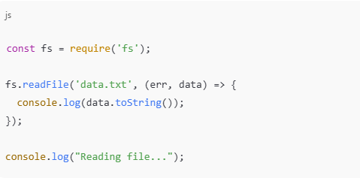
Task 4: Integrates Node.js core modules (like fs or http) with a custom module
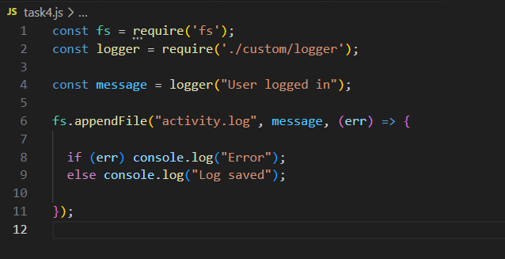
Output:
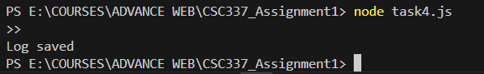
TASK 5: HTTP Server
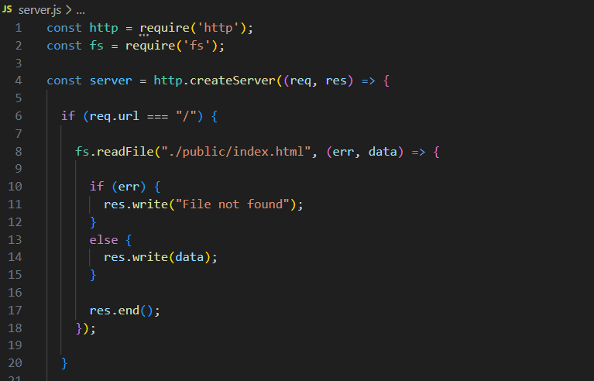
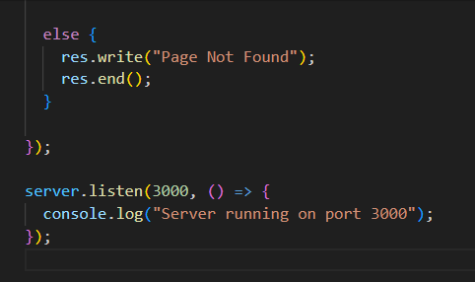
Output:

Hello world:

API:
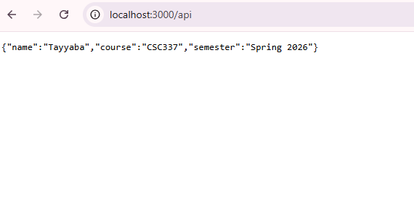
Page not Found:
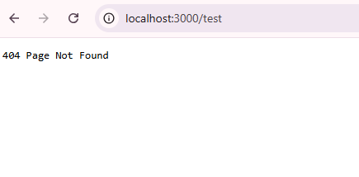
Task 6: program that parses query parameters from a URL (e.g., /product?id=123&category=books)
This program uses Node.js core url module to parse incoming URL requests.
The url.parse(req.url, true) function converts the URL into an object, from which query parameters can be accessed using parsedUrl.query.
This allows dynamic handling of different requests based on parameters, which is useful for APIs and web applications.
Product:
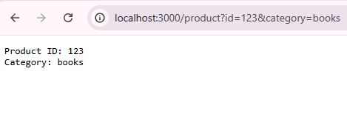
Task 7: Custom Error Handling
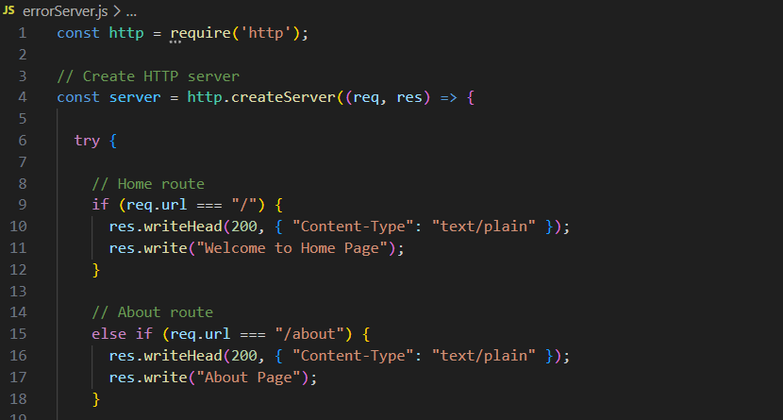
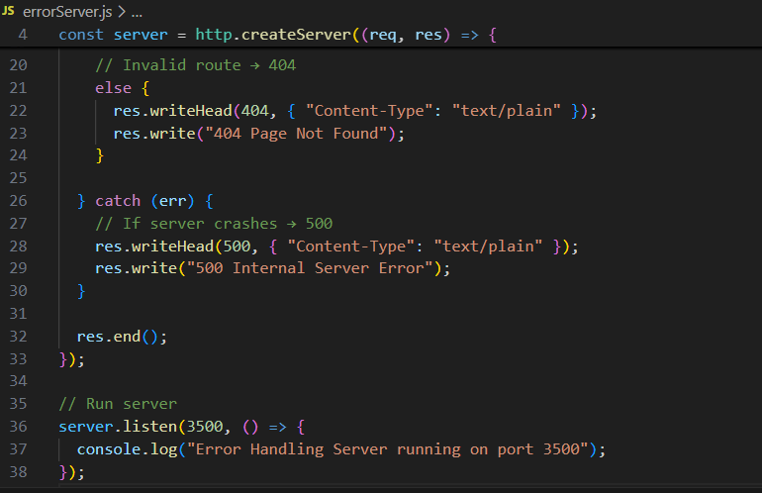
Outputs:



Task 8: Static File Server
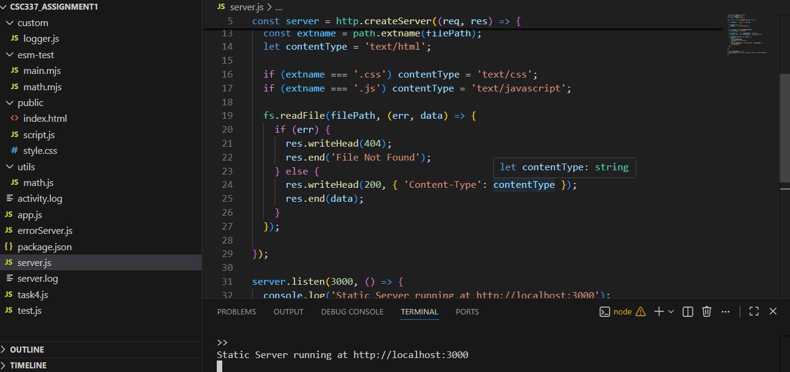
Output:

Task 9: Logging Mechanism for HTTP Server
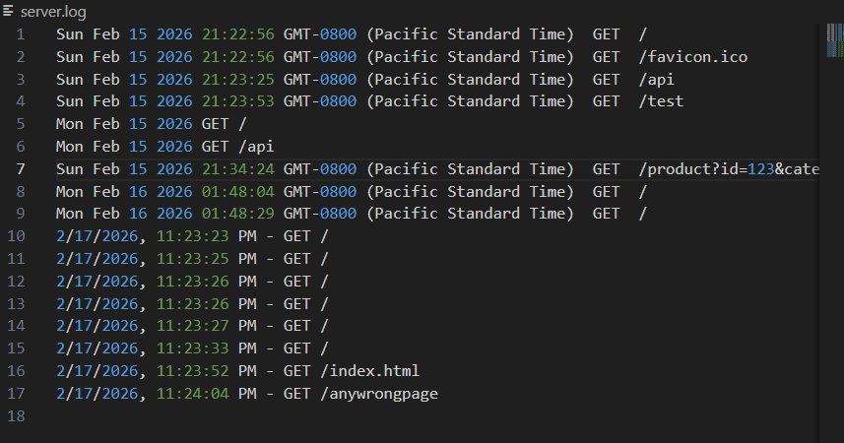

Task 10: Video Streaming Application
In this task, a Node.js HTTP server is created that streams video in chunks using the fs module. It supports partial streaming, allowing users to start playing the video without downloading the full file. This demonstrates how Node.js handles I/O efficiently for media content.

